1. Abstract
Real-estate pricing is influenced by a combination of measurable physical attributes of a property — such as its built-up area, number of bedrooms and bathrooms, and available parking space. This project presents a web-based machine learning application, House Price Prediction, that estimates the market price of a house from these four attributes using a multiple linear regression model. The application is built with Python and the Streamlit framework, and combines an interactive prediction interface with a filterable analytics dashboard and model-performance diagnostics, all rendered through Plotly charts.
The system was trained on a dataset of 545 housing records. On a held-out test set (20% of the data), the model achieves a coefficient of determination (R²) of 0.48, a Mean Absolute Error (MAE) of approximately ₹12.46 lakh, and a Root Mean Squared Error (RMSE) of approximately ₹16.15 lakh. The report documents the problem statement, dataset, system design, implementation, results, and the limitations and possible extensions of the current model.

2. Introduction
Estimating the price of a house is a problem that buyers, sellers, and real-estate agents face routinely. Traditional valuation relies on manual comparison with similar properties in a locality, which is time-consuming and inconsistent. Machine learning offers a data-driven alternative: given enough historical sales data, a model can learn the statistical relationship between a house's attributes and its selling price, and use that relationship to generate quick, consistent estimates for new properties.
This project implements such a system as an interactive web application. Rather than being a single-purpose script, the application is organised into three functional areas — a price prediction tool, an interactive filterable analytics dashboard, and a model-performance dashboard — so that a user can both obtain an estimate and understand the data and model behind it.

2.1 Problem Statement
Given a set of measurable house attributes — area, number of bedrooms, number of bathrooms, and number of parking spaces — predict the market price of the house, and present this prediction alongside supporting visual context so the user can judge how reliable and typical the estimate is.

2.2 Objectives
- Build a regression model that predicts house price from area, bedrooms, bathrooms, and parking.
- Provide an interactive, browser-based interface for entering house details and viewing a live prediction.
- Provide an interactive, filterable analytics dashboard — with sidebar slicers, live KPI cards, and multiple linked charts — to support exploratory analysis of pricing trends.
- Evaluate model performance quantitatively (MAE, RMSE, R²) and visually (actual-vs-predicted, residual plots).
- Package the entire workflow as a single deployable Streamlit application.

2.3 Scope
The scope of the current implementation is limited to a single, interpretable model (multiple linear regression) trained on four numeric features. It does not include categorical features that are commonly present in richer housing datasets (e.g. furnishing status, locality, or proximity to amenities), nor does it include model comparison across multiple algorithms. These are identified as directions for future work in Section 9.

3. Background and Related Concepts

3.1 Linear Regression
Linear regression models the target variable as a weighted sum of the input features plus an intercept term: price = b₀ + b₁×area + b₂×bedrooms + b₃×bathrooms + b₄×parking. The weights (coefficients) are chosen to minimise the sum of squared differences between predicted and actual prices on the training data (ordinary least squares). Its main advantages for this project are interpretability — each coefficient has a direct, explainable effect on price — and computational simplicity.

3.2 Streamlit
Streamlit is a Python framework for turning data scripts into shareable web applications without requiring front-end development experience. Widgets such as number inputs and buttons are declared directly in Python, and the framework automatically re-runs the script top-to-bottom whenever the user interacts with the page. This project relies on Streamlit's caching decorators to avoid redundant work on every re-run (see Section 5.2).

3.3 Plotly
Plotly is a graphing library used here to render interactive charts — bar charts, histograms, scatter plots, donut/pie charts, and a radar chart — that respond to zoom, pan, and hover without any additional code.

4. System Requirements

4.1 Software Requirements
Component | Requirement
Programming Language | Python 3.9+
Web Framework | Streamlit
Data Handling | pandas, NumPy
Machine Learning | scikit-learn
Visualisation | Plotly Express, Plotly Graph Objects
Operating System | Windows / macOS / Linux (any OS supporting Python)
IDE / Editor | VS Code, PyCharm, or any text editor

4.2 Hardware Requirements
- Processor: Any modern dual-core processor or higher
- RAM: 4 GB minimum (8 GB recommended)
- Storage: < 100 MB for the application and dataset
- Internet connection: required only to install dependencies and load Plotly's client-side assets

5. Dataset Description
The application uses HOUSE_PRICE_PREDICTION.csv, a tabular dataset of 545 house records with 5 columns and no missing values. Each row represents one property.
Column | Description | Type
price | Target variable — sale price of the house (₹) | Numeric
area | Built-up area of the house (sq. ft.) | Numeric
bedrooms | Number of bedrooms | Numeric (int)
bathrooms | Number of bathrooms | Numeric (int)
parking | Number of parking spaces | Numeric (int)

5.1 Descriptive Statistics
Statistic | price (₹) | area (sq ft) | bedrooms | bathrooms | parking
Mean | 47,66,729 | 5,150.5 | 2.97 | 1.29 | 0.69
Std. Dev. | 18,70,440 | 2,170.1 | 0.74 | 0.50 | 0.86
Minimum | 17,50,000 | 1,650 | 1 | 1 | 0
Median | 43,40,000 | 4,600 | 3 | 1 | 0
Maximum | 1,33,00,000 | 16,200 | 6 | 4 | 3

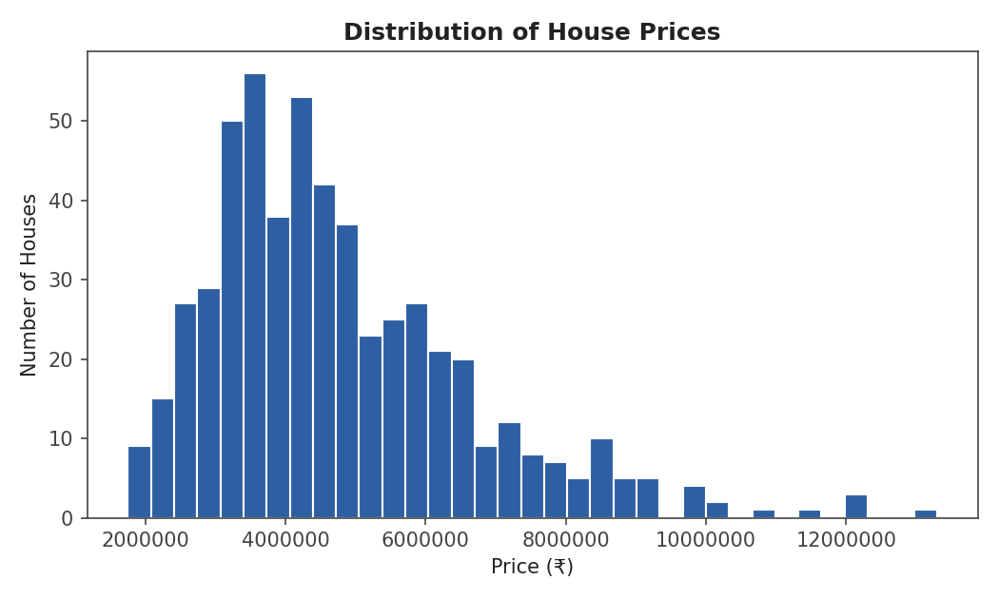
Fig. 5.1 – Distribution of house prices across the dataset

5.2 Correlation with Price
A Pearson correlation analysis was performed between each feature and the target variable, price. The results indicate that all four features are positively correlated with price, with area and bathrooms showing the strongest linear relationship.
Feature | Correlation with price
area | 0.536
bathrooms | 0.518
parking | 0.384
bedrooms | 0.366

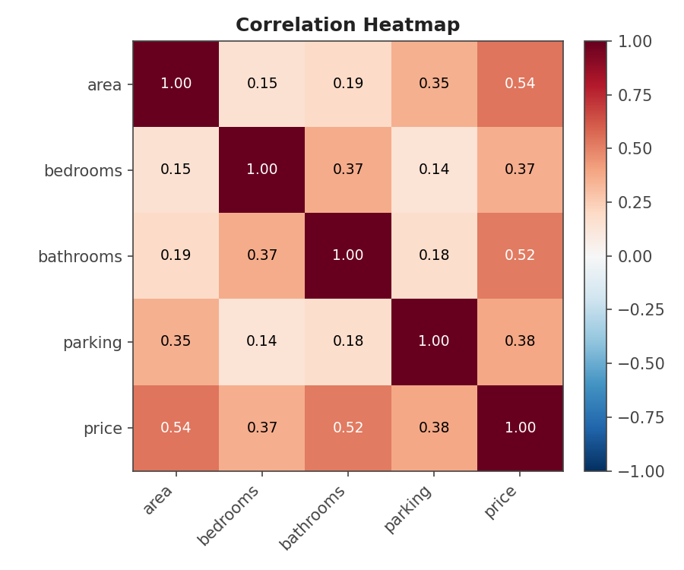
Fig. 5.2 – Correlation heatmap between features and price
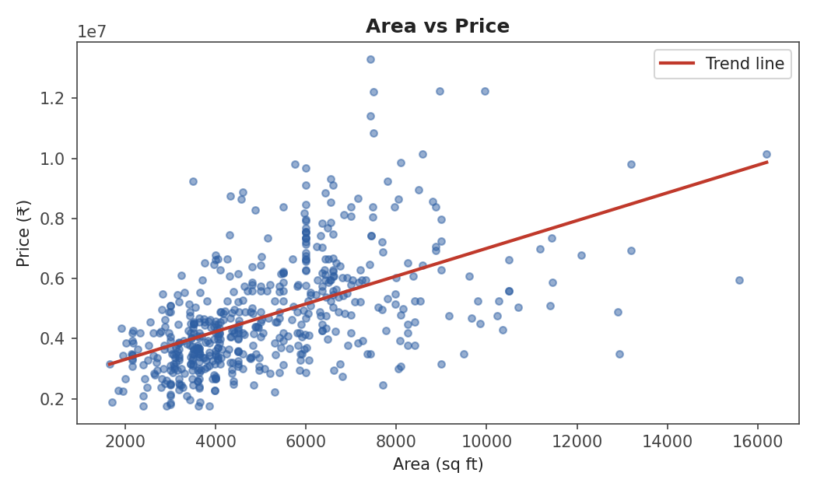
Fig. 5.3 – Area vs. price, with an ordinary-least-squares trend line

6. System Design and Methodology

6.1 Overall Architecture
The application follows a simple, single-tier architecture in which data loading, model training, and presentation all occur within one Streamlit process. This is well suited to the scale of the dataset (545 rows) and to Streamlit's caching model, which avoids the need for a separate backend service.
- Data Layer: CSV file (HOUSE_PRICE_PREDICTION.csv) read into a pandas DataFrame.
- Model Layer: scikit-learn LinearRegression trained on an 80/20 train–test split.
- Presentation Layer: Streamlit UI organised into three tabs, with Plotly charts for all visual output.

6.2 Workflow
- 1. The CSV dataset is loaded and validated (required columns are checked).
- 2. The dataset is split into training (80%) and testing (20%) subsets using a fixed random seed for reproducibility.
- 3. A Linear Regression model is trained on the training subset.
- 4. The trained model is evaluated on the test subset using MAE, RMSE, and R².
- 5. The user enters house details through the UI; the trained model predicts a price on demand.
- 6. Supporting visualisations (radar comparison, price-distribution position, exploratory charts, performance diagnostics) are generated from the same trained model and dataset.

6.3 Caching Strategy
Two Streamlit caching decorators are used to avoid repeating expensive work on every UI interaction, since Streamlit re-executes the whole script on each rerun:
- @st.cache_data on the data-loading function — caches the DataFrame returned by reading the CSV.
- @st.cache_resource on the model-training function — caches the trained model object (and its computed metrics), since model objects should not be copied or serialised the way plain data is.

7. Implementation
The application is implemented as a single Python script using Streamlit, pandas, NumPy, scikit-learn, and Plotly. The key implementation components are described below.

7.1 Model Training
The training routine selects the four feature columns (area, bedrooms, bathrooms, parking) and the target column (price), performs an 80/20 train–test split with a fixed random_state of 42 for reproducibility, and fits a scikit-learn LinearRegression model. Evaluation metrics and per-feature coefficients are computed immediately after training and cached alongside the model.
X_train, X_test, y_train, y_test = train_test_split(
X, y, test_size=0.2, random_state=42
)
model = LinearRegression()
model.fit(X_train, y_train)

7.2 Application Structure — Three Tabs
The user interface is organised into three tabs using st.tabs(), each addressing a distinct objective of the project:

7.2.1 Predict Tab
- Accepts area, bedrooms, bathrooms, and parking as numeric inputs.
- Includes a light input-sanity check (a warning if bathrooms greatly exceed bedrooms).
- On clicking “Predict House Price,” the model produces a point estimate, floored at ₹0.
- Displays an approximate price range using the model's MAE as a margin of error.
- Shows a radar chart comparing the entered house's normalised feature values against the dataset average.
- Shows a histogram of the price distribution with the new prediction marked as a vertical line, so the user can see where their estimate falls relative to the whole dataset.

7.2.2 Dashboard Tab
- Provides sidebar filters (slicers) for bedrooms, bathrooms, parking, area range, and price range, with a "Clear all filters" control; all charts and KPI cards on the tab recompute live from the filtered subset of the dataset.
- Displays five KPI cards — Average Price, Average Bathrooms, Median Bedrooms, Average Parking, and Average Area — summarising the currently filtered set of properties.
- Renders a grid of eight linked charts: average price by bedrooms, by bathrooms, and by parking (bar charts); house area vs. price (scatter, coloured by bedrooms); price distribution (histogram); bedrooms split (donut chart); parking mix (pie chart); and average price by bedrooms and bathrooms combined (stacked bar chart).
- Uses a consistent navy/red colour theme and card-style KPI styling (via light custom CSS) so the dashboard reads as a single cohesive analytics view rather than a set of separate plots.

7.2.3 Model Performance Tab
- Displays MAE, RMSE, R², and the test-set size as summary metric cards.
- Plots Actual vs. Predicted price for the test set, with a diagonal reference line for a perfect model.
- Plots residuals (actual − predicted) against predicted price, and a histogram of residuals, to check for bias and heteroscedasticity.
- Plots the regression coefficients as a horizontal bar chart to show each feature's effect on predicted price.

7.3 Error Handling
The application checks that the CSV file exists and that all required columns are present before training begins; if either check fails, it displays a descriptive error message via st.error() and halts execution with st.stop(), rather than failing with a raw Python traceback.

8. Results and Analysis

8.1 Model Performance Metrics
The model was evaluated on the held-out test set of 109 rows (20% of 545 total records, with 436 rows used for training). The results are summarised below:
Metric | Value | Interpretation
MAE | ₹12,45,976 | Average absolute error in predicted price
RMSE | ₹16,15,034 | Root-mean-square error; penalises larger errors more
R² Score | 0.484 | The model explains ≈48% of the variance in price
Train / Test split | 436 / 109 rows | 80% / 20% split, random_state = 42

8.2 Feature Coefficients
The fitted regression coefficients indicate the change in predicted price (in ₹) for a one-unit increase in each feature, holding the other features constant:
Feature | Coefficient (₹) | Interpretation
bathrooms | 13,56,851 | Largest positive effect — each additional bathroom adds ≈13.6 lakh
bedrooms | 3,41,944 | Each additional bedroom adds ≈3.4 lakh
parking | 3,22,224 | Each additional parking space adds ≈3.2 lakh
area | 307 | Each additional sq. ft. adds ≈₹307

The intercept term is approximately ₹1,73,254, representing the model's baseline price when all features are zero (an extrapolation with no direct real-world meaning, but mathematically required by the linear form).

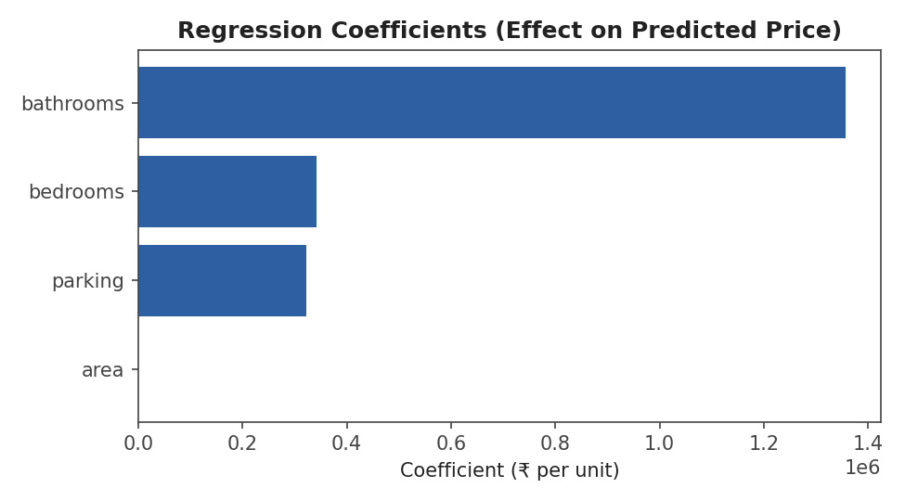
Fig. 8.1 – Regression coefficients: effect of each feature on predicted price

8.3 Visual Diagnostics
The following plots visualise model quality on the held-out test set. In the Actual vs. Predicted plot, points closer to the dashed diagonal indicate more accurate predictions. In the residual plot, points scattered evenly around the zero line (with no funnel or curved pattern) indicate that errors are not systematically biased for any price range.
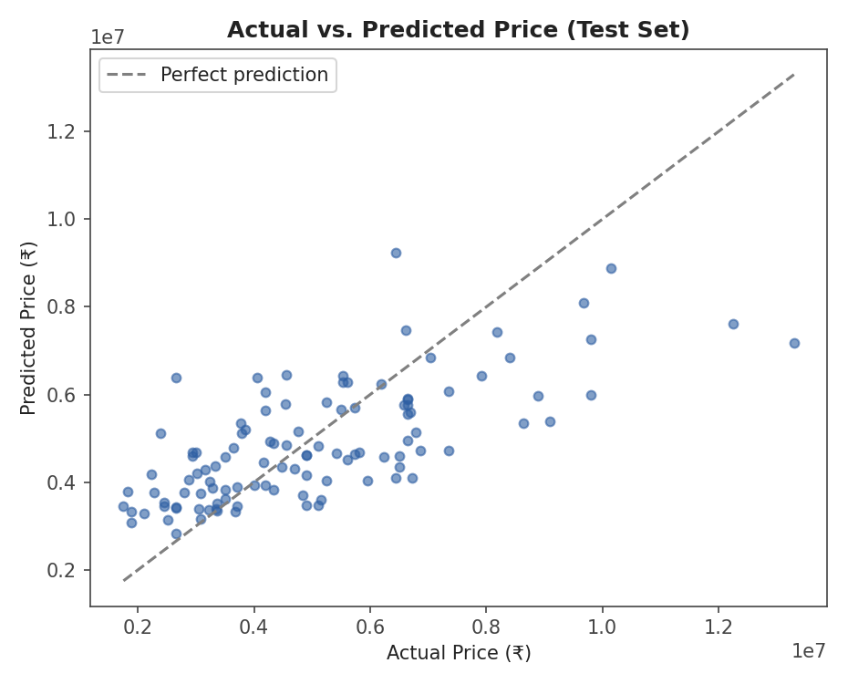
Fig. 8.2 – Actual vs. Predicted price on the test set
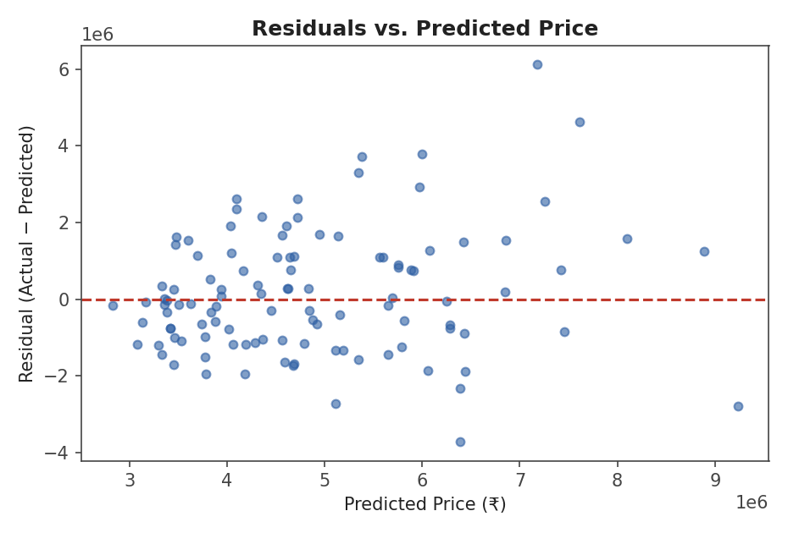
Fig. 8.3 – Residuals vs. predicted price

8.4 Discussion
An R² of 0.48 indicates that the four available features explain roughly half of the variation in house price, which is a reasonable baseline for a simple linear model but also indicates that other, unmodelled factors — such as location, age of the property, furnishing, or proximity to amenities — contribute meaningfully to price and are not captured here. The residual plots (Section 7.2.3) are useful for visually confirming whether prediction errors are roughly random and centred at zero (a well-behaved model) or show a pattern (indicating the model is systematically over- or under-predicting for certain price ranges).

9. Conclusion
This project successfully demonstrates an end-to-end machine learning workflow — from raw data to a deployed, interactive prediction tool — using a multiple linear regression model to estimate house prices from four structural attributes. Beyond the prediction itself, the application provides exploratory and diagnostic visualisations that make the model's behaviour transparent to the end user, which is a valuable property for any applied ML system. The resulting model achieves moderate predictive accuracy (R² ≈ 0.48), consistent with the limited number of features available in the dataset.

10. Future Scope
- Incorporate additional features present in richer housing datasets, such as locality, furnishing status, house age, and proximity to amenities.
- Compare Linear Regression against more expressive models such as Random Forest, Gradient Boosting (XGBoost/LightGBM), or regularised regression (Ridge/Lasso), and select the best performer via cross-validation.
- Add feature engineering (e.g. price per square foot, interaction terms) and outlier handling to improve model robustness.
- Persist trained models to disk and allow scheduled re-training as new data becomes available.
- Deploy the application publicly (e.g. via Streamlit Community Cloud) with user authentication and a database backend in place of a static CSV.
- Extend the dashboard with drill-through detail views and chart/data export options once additional (categorical) features become available.

11. References
- Streamlit Documentation — https://docs.streamlit.io
- scikit-learn Documentation — https://scikit-learn.org/stable/
- Plotly Python Graphing Library — https://plotly.com/python/
- pandas Documentation — https://pandas.pydata.org/docs/
- Pedregosa et al., “Scikit-learn: Machine Learning in Python,” Journal of Machine Learning Research, 2011.
- Project dataset: HOUSE_PRICE_PREDICTION.csv (545 records, course-provided / Kaggle-style housing dataset).

Acknowledgement
I would like to express my sincere gratitude to my project guide, [Mr. Kartik Hooda ], for their invaluable guidance, encouragement, and support throughout the course of this project. I also thank the faculty of the [ BCA ] and my institution, [ Midnapore College (Autonomous)], for providing the resources and environment necessary to complete this work. Finally, I thank my family and friends for their constant support.

